Valeria Anel Duque Salgado *NAO ID: 3306 08/09/2025*

***GitHub and Digital Repository Management***

*IN-MEXICO PROGRAM BACKEND*

*DEVELOPER CERTIFICATION*

Contents:

**GITHUB ACCOUNT CREATION:** 3

**GIT INSTALLATION:** 4

**1.** **DOWNLOAD THE GIT SETUP FILES:** 4

2. **VERIFICATION:** 6

**SSH KEY GENERATION AND CONFIGURATION:** 7

**3.** **CREATION OF A SSH KEY ON GITBASH:** 7

4. **CONNECT GIT BASH WITH GITHUB:** 8

5. **VERIFY ON GITBASH:** 10

# **GITHUB ACCOUNT CREATION:**

Go to <https://github.com/> and click on Sign Up:

Then you can create an account through Google or with an email:

Once filled the information spaces and submitted the necessary information, the page will lead you to your new account:

# **GIT INSTALLATION:**

1. **DOWNLOAD THE GIT SETUP FILES:**

Go to the Git for Windows page (<https://gitforwindows.org/>) and download the setup files:

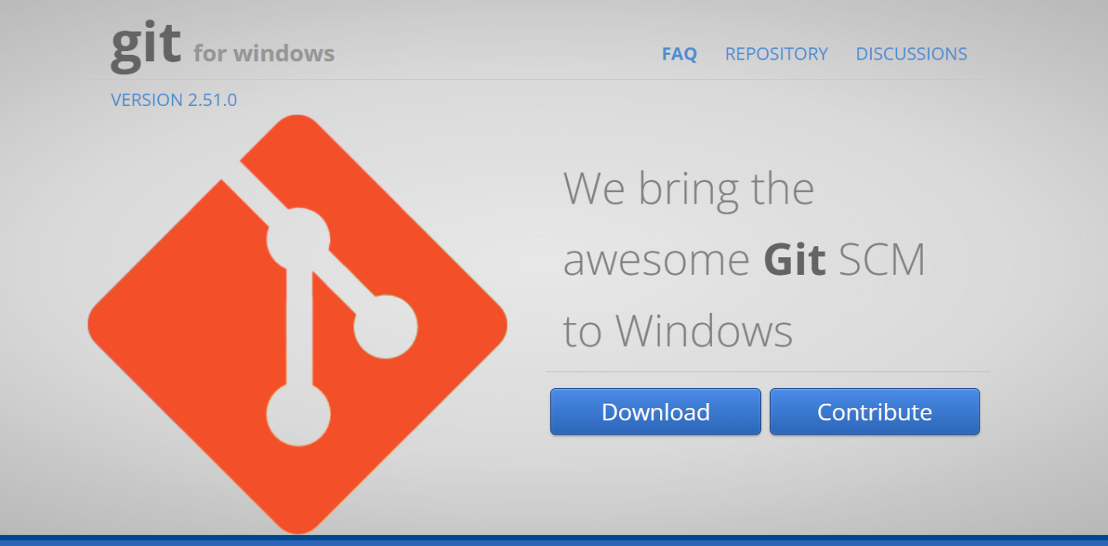

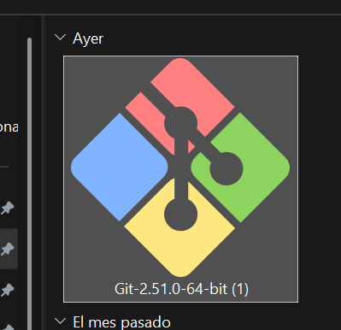Once downloaded, start the installation and grant the corresponding permission:

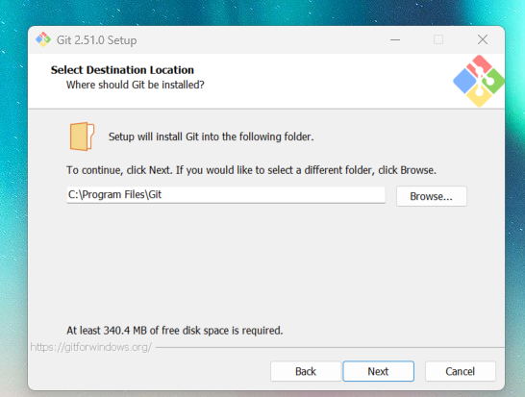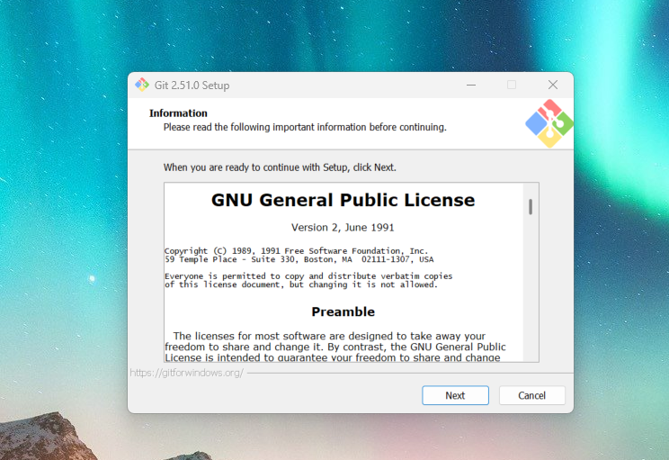 Start the installation system and select the Destination Location:

Select your installation preferences and let it install itself:

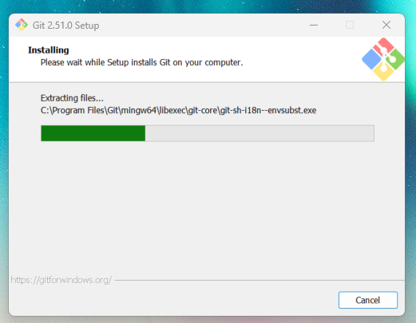

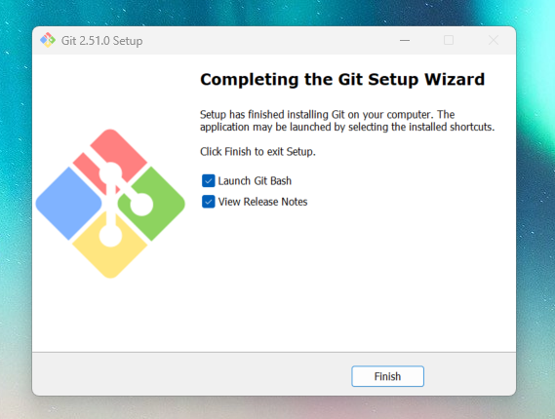Finish the installation process:

1. **VERIFICATION:**

Open Git Bash and write down “git version” on the terminal to make sure everything is correct:

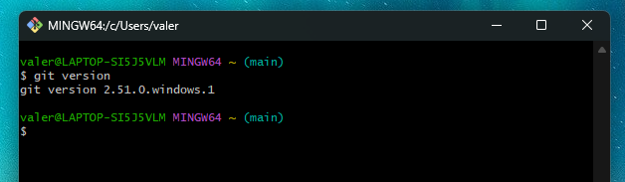

# **SSH KEY GENERATION AND CONFIGURATION:**

1. **CREATION OF A SSH KEY ON GITBASH:**

Open GitBash and execute the command ssh-keygen -t ed25519 -C [your_email@example.com](mailto:your_email@example.com), and replace the email example with your own email

The system asks for a file to save the key, if you want to accept the default location of the key just press “enter”:

If it already exists, you can override it:



****Then it must be added a passphrase. And enter the same passphrase again for confirmation:

If everything is set up correctly, this is a message you shall receive:



1. **CONNECT GIT BASH WITH GITHUB:**

Write down on GitBash this command ls -al ~/.ssh, this is the outcome:

We need the one ending with .pub , then we write the command cat ~/.ssh/id_rsa.pub, or in this case; cat ~/.ssh/id_ed25519.pub.

This is the outcome:

Full code is needed. It must be copied.

Then, we go to GitHub → Settings → SSH and GPG keys:

Click on “New SSH Key”:

After that, a ssh key creation page opens. The information must be filled up.

The key created on GitBash and previously copied will be placed in the last section of the page:

Once everything is done, click on “Add SSH Key” button:

Remember that your code must include email as well. If everything is correct, this message will appear:

1. **VERIFY ON GITBASH:**

To verify the connection with the account, write on GitBash the next command:

ssh -T [git@github.com](mailto:git@github.com)

GitBash Will ask you for your passphrase, previously created:

If it is connected, this message will appear:

Can also be checked, by adding the command the “git config --get user.email” onto GitBash:

Or, can write the command “git config –list”, which will bring the full list of the GitBash configuration:

Notes for feedback:

It is easy to install by creating the SSH key with GitBash and linking it to GitHub from its platform.

The keys must be saved for later use.

The repositories can be linked later without any problems.